Airbnb analysis
Comparative Dashboard Analysis: Chicago vs New Orleans

🧩 Project Overview
This project focuses on using Tableau Desktop to visualize and analyze Airbnb listings data for the cities of Chicago and New Orleans.
By transforming EDA insights into interactive dashboards, we aim to highlight pricing trends, popular neighborhoods, and host behaviors, providing actionable insights for business decision-making.

📁 Dataset Details
- Source: InsideAirbnb.com
- Cities Covered: Chicago and New Orleans
- Key Attributes:
  - id – Unique listing ID
  - host_id – Host identification
  - room_type – Room category
  - neighbourhood – Location area
  - price, availability_365, number_of_reviews
  - latitude, longitude

🧹 Data Cleaning & Preparation
- Removed duplicates and handled missing values
- Standardized inconsistent neighbourhood names (e.g., spelling, casing) using Tableau Prep
- Derived new fields like:
  - Listings per Host
  - Avg Reviews per Month
- Handled extreme outliers in price and reviews

📊 Dashboard Structure
The visual analysis is divided into four key sections:
- Overview Dashboard
- Property Analysis
- Pricing Analysis
- Host Analysis

📍 Overview Dashboard

Visuals Created:
- Total Listings by City – Bar Chart
- Room Type Distribution – Pie Chart
- Map of Listings – Symbol Map with filters for city & room type

Insights:
- Chicago has more active listings than New Orleans
- Entire home/apartment listings dominate both cities
- Listings are concentrated in central urban areas

🧱 Property Analysis

Visuals Created:
- Top Neighbourhoods by Listings – Bar Chart
- Average Price by Neighbourhood – Heatmap
- (Property Type Distribution was skipped due to unavailable data)

Insights:
- Certain neighborhoods have a large number of listings but are budget-friendly
- Luxury neighborhoods are clearly visible on pricing heatmaps

💰 Pricing Analysis

Visuals Created:
- Price vs Number of Reviews – Scatter Plot
- Average Price by Room Type & City – Grouped Bar Chart
- Pricing Heatmap by Neighbourhood – City-wise heat visual

Insights:
- Listings with higher reviews generally have higher pricing
- Entire homes in Chicago are priced significantly higher than in New Orleans
- Shared rooms and private rooms follow different pricing trends

👤 Host Analysis

Visuals Created:
- Listings per Host – Histogram
- Average Reviews per Month by Host – Bar Chart
- Price Comparison (Single vs Multi-listing Hosts) – Box Plot

Insights:
- Most hosts operate only a single listing (casual hosts)
- Multi-listing hosts charge more and receive more reviews
- Higher engagement is found in hosts with multiple listings

✅ Conclusion
- Tableau enables powerful visual storytelling of Airbnb market behavior
- Chicago leads in listings and pricing, but New Orleans offers more affordable options
- Hosts with multiple listings show commercial behavior and higher engagement
- The insights can be used by Airbnb strategists, investors, and urban planners

🛠️ Tools Used
- Tableau Desktop – For dashboard building
- Jupyter Notebook – Initial data cleaning
- Tableau Prep – For data transformation
- PowerPoint/Google Docs – For presentation/reporting
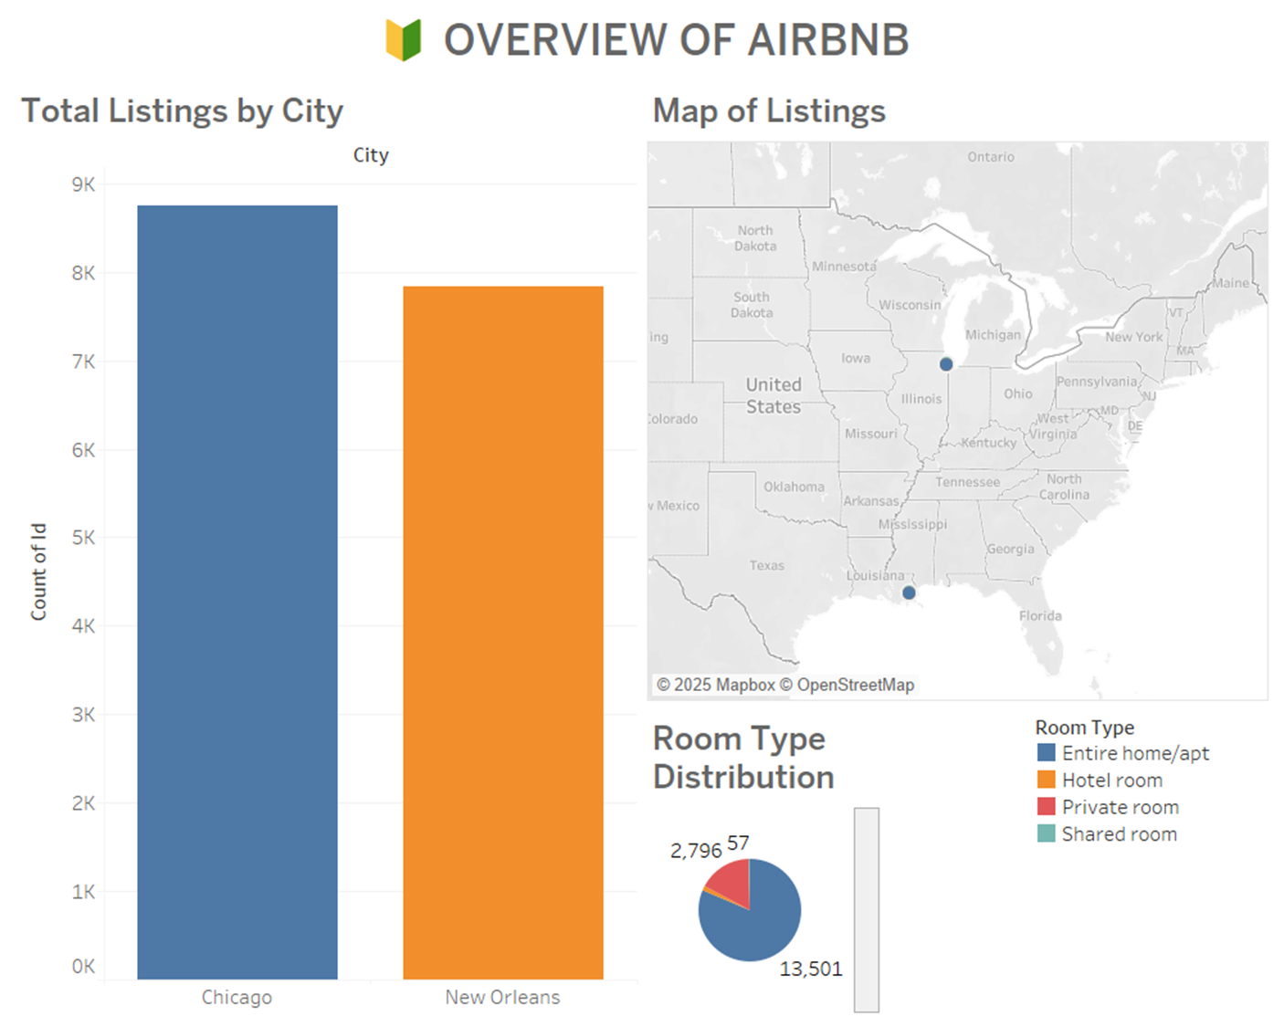📌 Visuals Included:
- Total Listings by City (Bar Chart)
- Room Type Distribution (Pie Chart)
- Map of Listings Distribution (Symbol Map with Filters)

🧠 Insights:
- Chicago has a significantly higher number of listings compared to New Orleans.
- The dominant room type in both cities is Entire home/apt, followed by Private rooms.
- Map visualization shows listing hotspots clustered in downtown and popular tourist zones of both cities.
- Filters like city and room type enable quick comparisons and dynamic exploration of the listing spread.
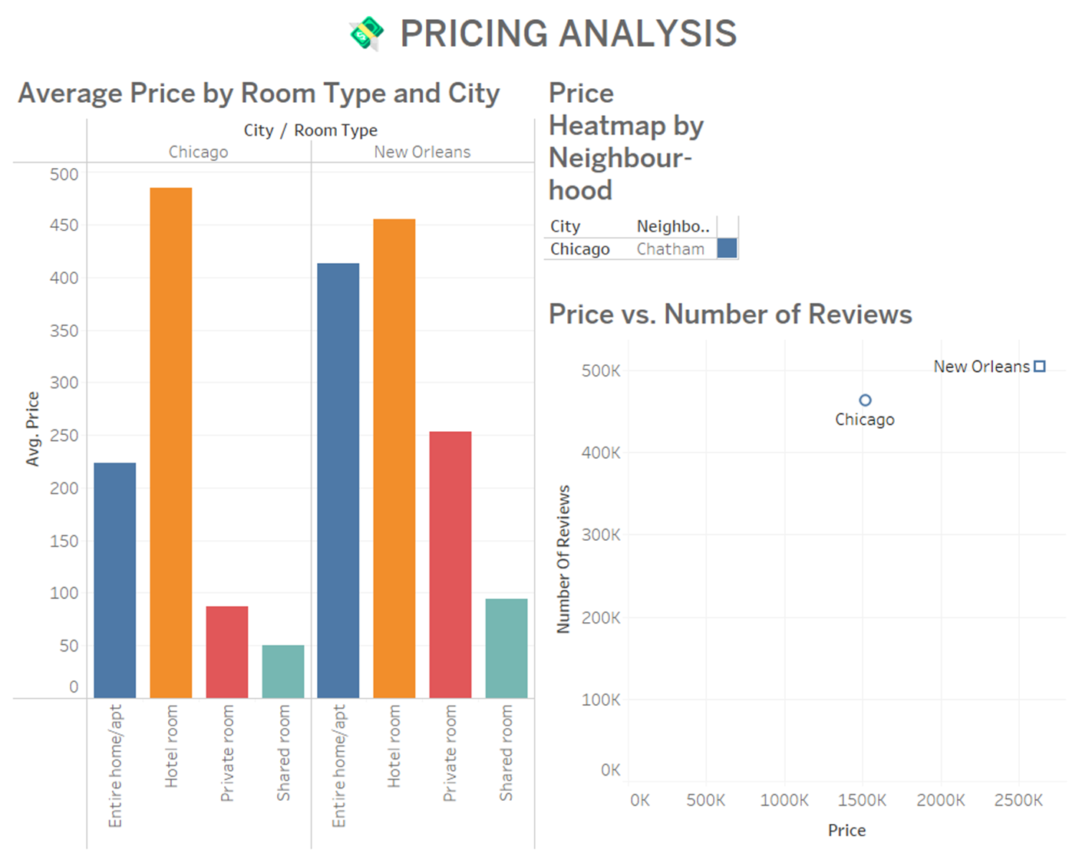

💰 PRICING ANALYSIS

📌 Visuals Included:
- Price vs Number of Reviews (Scatter Plot)
- Average Price by Room Type and City (Grouped Bar Chart)
- Price Heatmap by Neighbourhood (Heatmap)

🧠 Insights:
- Listings with more reviews often have higher prices, indicating popularity and guest satisfaction.
- Entire home/apartment listings command higher prices across both cities.
- Heatmaps clearly show pricing clusters and help pinpoint budget-friendly and premium areas.
- Price strategy can be optimized by comparing room type and location.

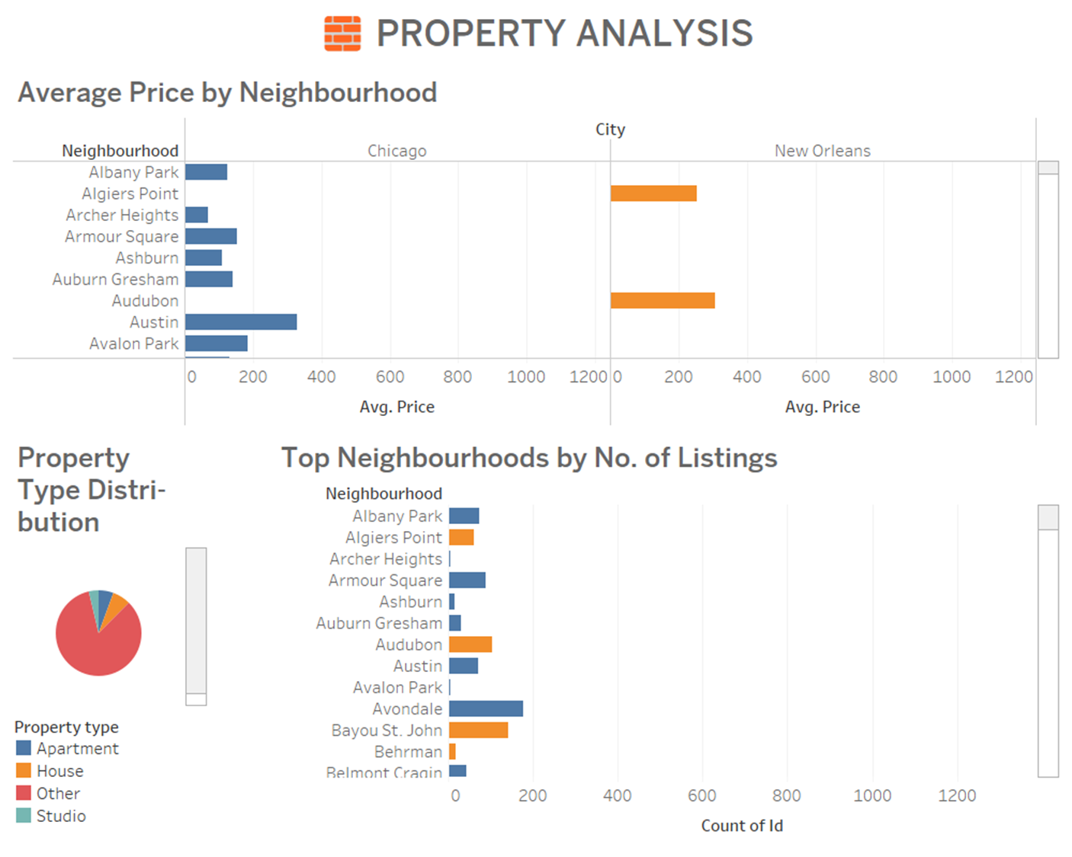

🧱 PROPERTY ANALYSIS

📌 Visuals Included:
- Top Neighbourhoods by Number of Listings (Horizontal Bar Chart)
- Average Price by Neighbourhood (Bar Chart or Heatmap)
- (Property Type Distribution chart skipped due to missing data)

🧠 Insights:
- Listings are concentrated in a few major neighbourhoods in both cities, e.g., Lakeview and Near North Side in Chicago.
- Average prices vary significantly, with premium areas showing much higher rates.
- This analysis helps identify hotspot neighborhoods for investment or tourism targeting.

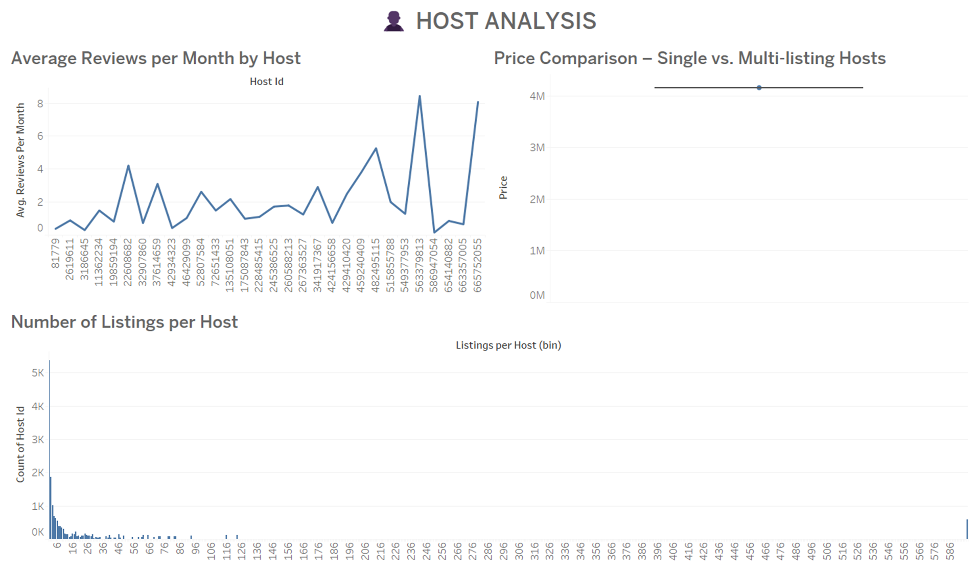

👤 HOST ANALYSIS

📌 Visuals Included:
- Number of Listings per Host (Histogram)
- Average Reviews per Month by Host (Bar Chart or Line Chart)
- Price Comparison – Single vs Multi-listing Hosts (Box Plot)

🧠 Insights:
- Most hosts are individuals with a single listing, but a few multi-listing hosts dominate the market.
- Multi-listing hosts tend to receive more reviews per month, indicating higher guest traffic or professional hosting.
- Box plot comparison shows that commercial hosts often charge higher prices than casual hosts.
- Helps understand host segmentation: casual vs commercial.

